# What is the most popular server programming language?

In order to have empirical evidence for which server programming language is the most popular, a web technology survey report that gets updated daily can be viewed at W3Techs.com. Below is a graph from their survey report showing that over 80% of websites use PHP and that this market share percentage has been fairly consistent over the past 12 months, indicating that PHP is neither increasing nor declining in popularity. The other interesting part of the graph is that the next runner up is ASP.NET at well under 20% and the others are below 1% of market share. Many other programming languages were also part of the survey, but if they scored under 0.1% market share, they were not even shown on the graph. So, it is safe to say that PHP is the most popular server programming language at the time of this writing.

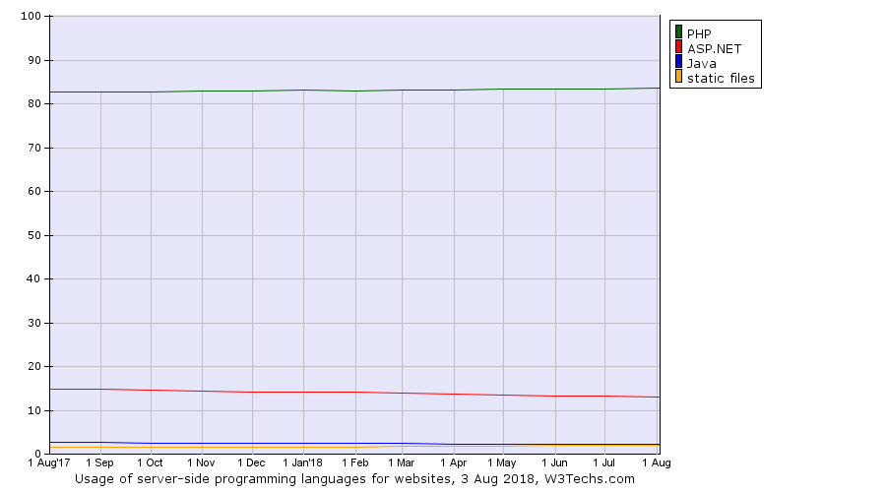

(”Historical trends in the usage of server-side programming languages for websites”, August 3, 2018).

# Can you find which web application or online systems are programmed with PHP?

Here are list of websites that use PHP

* [Facebook.com](https://w3techs.com/sites/info/facebook.com)
* [Wikipedia.org](https://w3techs.com/sites/info/wikipedia.org)
* [Qq.com](https://w3techs.com/sites/info/qq.com)
* [Vk.com](https://w3techs.com/sites/info/vk.com)
* [Sina.com.cn](https://w3techs.com/sites/info/sina.com.cn)
* [360.cn](https://w3techs.com/sites/info/360.cn)
* [Csdn.net](https://w3techs.com/sites/info/csdn.net)
* [Wordpress.com](https://w3techs.com/sites/info/wordpress.com)
* [Deloton.com](https://w3techs.com/sites/info/deloton.com)
* [Pinterest.com](https://w3techs.com/sites/info/pinterest.com)

(Excerpted from ”Usage statistics and market share of PHP for websites”, August 3, 2018).)

Moreover, according to the learning guide this week, our own UoPeople.com also uses PHP. It is easy to tell if a web page is using php, as the url will have a file with a .php ending.

# Why do you think that most web pages today require server side programming?

“An increasingly common trend in web design is for all content on a website to be stored in a database” (”Building the Web: Beyond HTML”, 2018). For example, login data like usernames and passwords gets stored in databases on web servers along with other information about the user. If you type in a valid user name and the right password (in other words the pair matches a combination in the database), then a server-side script will retrieve the appropriate data and use it to customize the web page for you. Additionally, based on our previous coursework on static web pages versus Web 2.0 sites and Content Management Systems, we know that more and more websites are allowing users to add content to web pages. Since most users may not know HTML, the websites are coded so that a user need only write content into a web form, and select “Save”. “A server-side script then saves the content to the database, where it sits in storage until someone requests it” (”Building the Web: Beyond HTML”, 2018). A perfect example of this is our UoPeople discussion forums. To upload my discussion post, I simply write into the text field and hit submit. The server stores my post to a database. Later, using their browser, other students can view my post along with everyone else’s.

# Why must a web developer learn more than just client side technologies?

It is generally known that web development is broken down into two parts, the client-side (front-end) and the server-side (back-end). It is still useful to know how the back-end works even if you are focused on front-end development.(“Learn web development”, 2018). In fact, advanced front-end developers will often have expertise in both client-side and server-side technologies (Shiotsu, Y., 2018), with many programmers delivering a complete Software as a Service (SaaS) site, “including a dynamic web client, server-side business logic, a scalable database, deployment, and operational support” (Yared, November 8, 2014). A full-stack programmer eliminates the need for different developers at different tiers of application from needing to communicate to each other, which takes time. A full-stack programmer can add a feature to an application at all tiers and speed up feature deployment. Considering most software startup companies are deploying their product on the web rather than on a disk, being able to do full-stack development would be increasingly important for timely deployment.

However, as technology becomes more complex, with more features added to websites, hiring full-stack developers with deep skills in all areas may can become difficult (likened to finding a unicorn). Therefore, as technology becomes more complex, full stack integrators, who only have a surface understanding of all the technologies and how they come together may be required, along with programmers with deeper skills in particular areas (Yared, November 8, 2014). Ar a result of complexity, the type of programmer that is needed may fluctuate as technology evolves. At the time of this writing, a search of Indeed.com shows that the top need today in web programming is the front-end developer (with 24,005 job openings), followed by full stack developers (at 14,305 jobs), and then the back-end developer (with 8,069 openings).

# References

”Building the Web: Beyond HTML”. (2018). Web Design & Development I, Version 2.0, Student Version. University of Washington. Retrieved from <https://www.washington.edu/accesscomputing/webd2/student/unit5/module1/beyondhtml.html>

”Historical trends in the usage of server-side programming languages for websites”. (August 3, 2018). W3Techs Web Technology Surveys. Retrieved from

<https://w3techs.com/technologies/history_overview/programming_language>

Indeed.com (n.d.) Retrieved from [http://Indeed.com](http://indeed.com)

“Learn web development”. (2018). MDN web docs. Mozilla. Retrieved from <https://developer.mozilla.org/en-US/docs/Learn>

Shiotsu, Y. (2018). “Writing a Job Description to Find a Great Front-End Developer”. Retrieved from <https://www.upwork.com/hiring/development/writing-job-description-find-great-front-end-developer/>

”Usage statistics and market share of PHP for websites”. (August 3, 2018). W3Techs Web Technology Surveys. Retrieved from <https://w3techs.com/technologies/details/pl-php/all/all>

Yared, P. (November 8, 2014). “The Rise And Fall Of The Full Stack Developer”. Retrieved from <https://techcrunch.com/2014/11/08/the-rise-and-fall-of-the-full-stack-developer/>